

**Discipline**

**Configure a RDS with Postgres SQL and create 2 table in it.**

**CS5002**

Activity-17

**Sheikh Muhammed Tadeeb (AU19B1014)**

* **Problem Statement:**

Configure a RDS with Postgres SQL and create 2 table in it.

Table 1: Books, with attribute as Name, Pages, Cost and Language.

Table 2: Movies, with Attribute, Movie Name: Actor, Director, Release Year.

* **Solution:**

**Step 1:** Creating Database with the settings below.

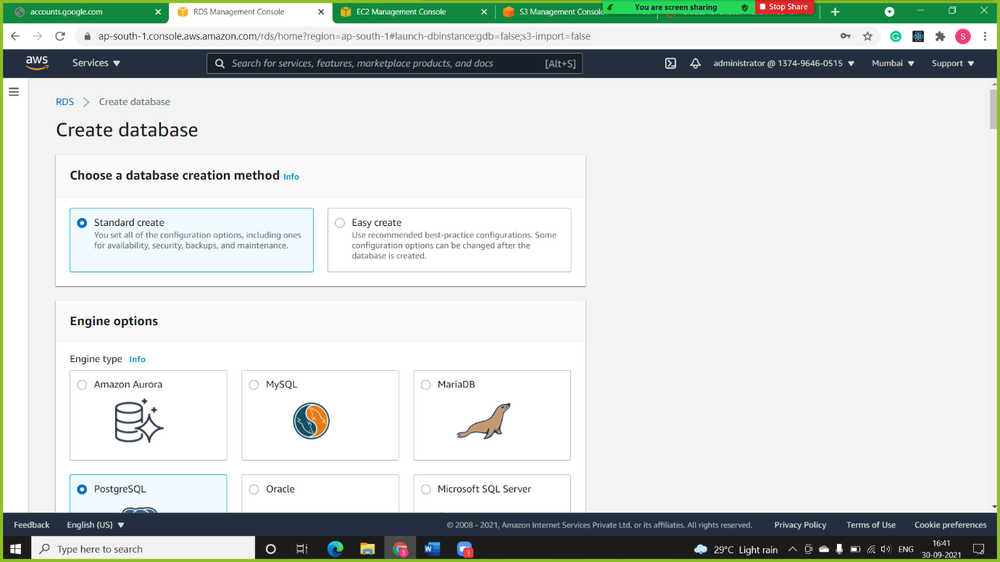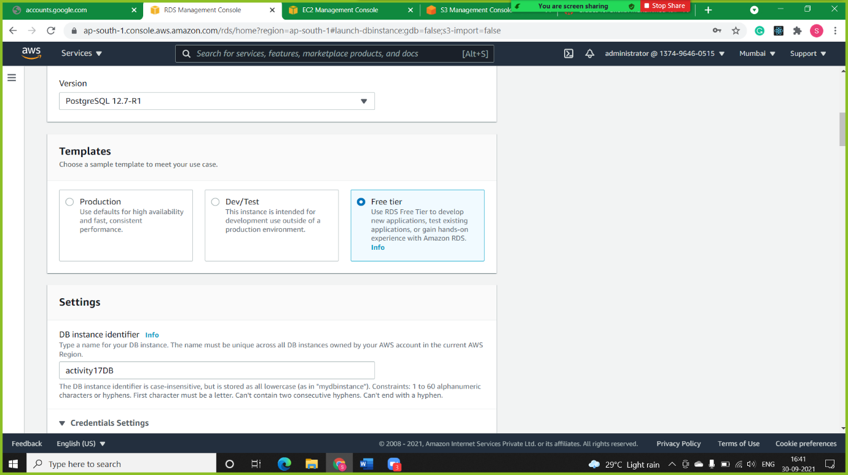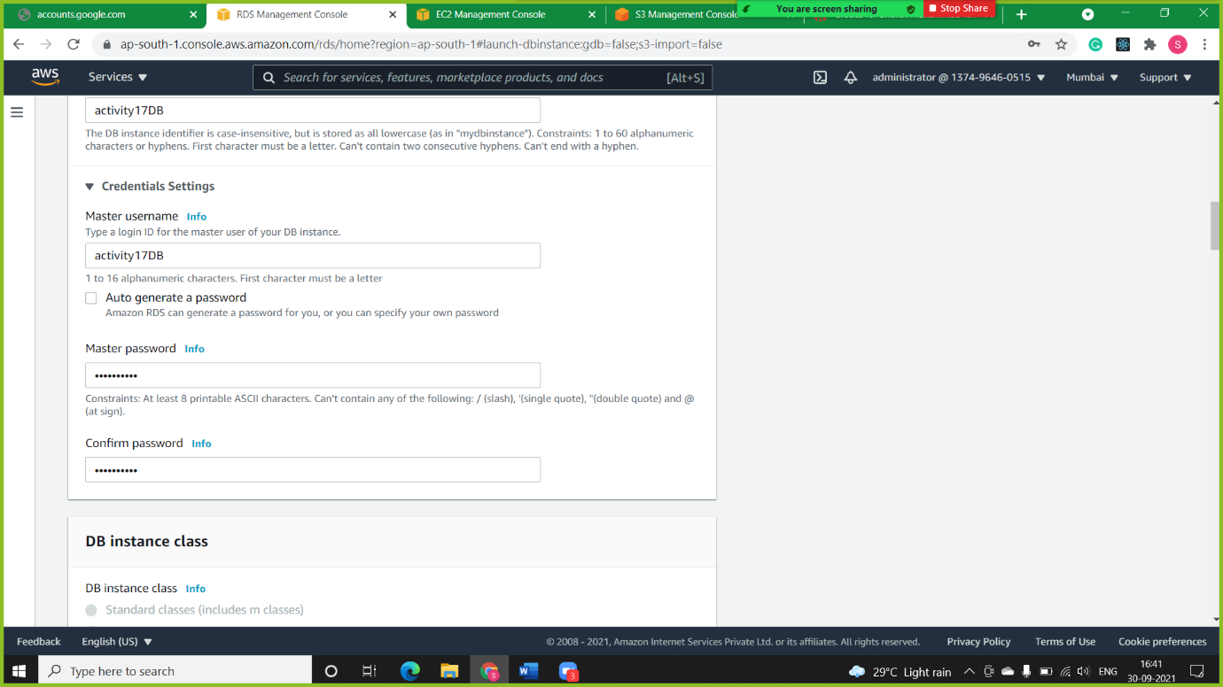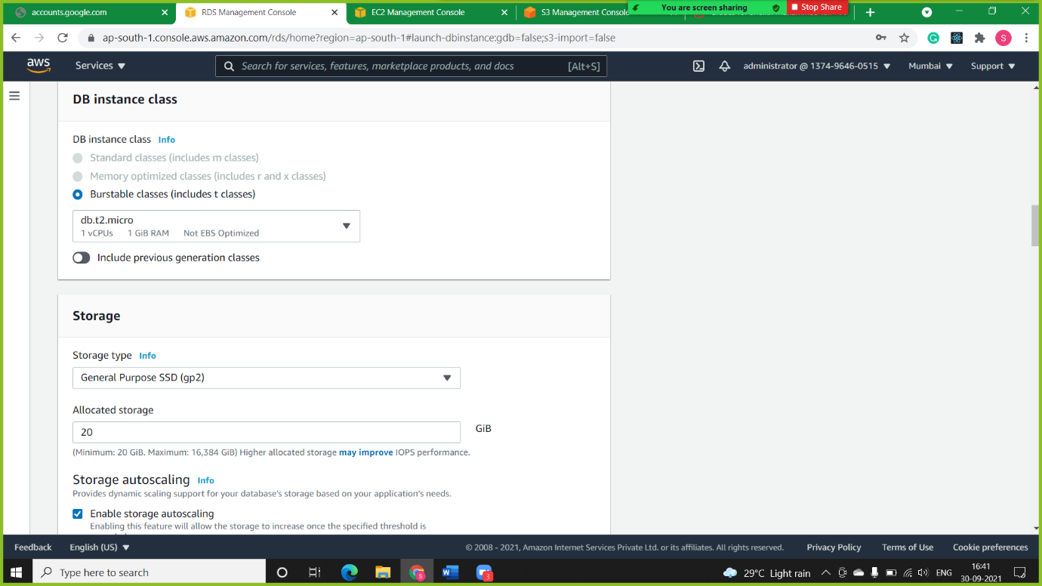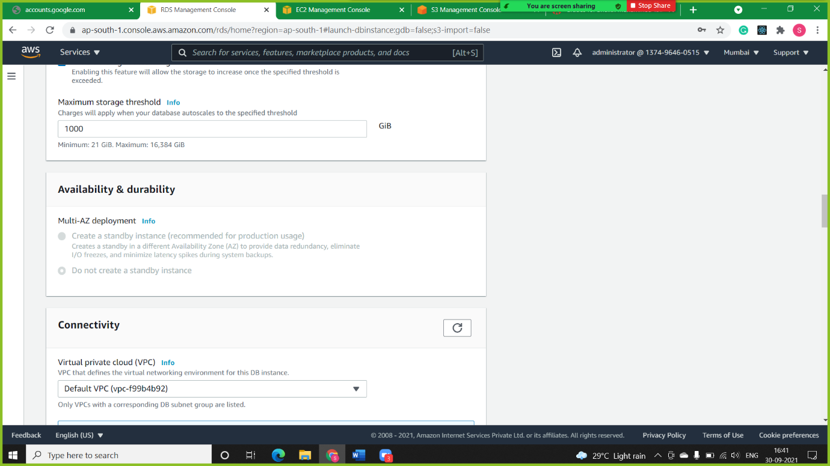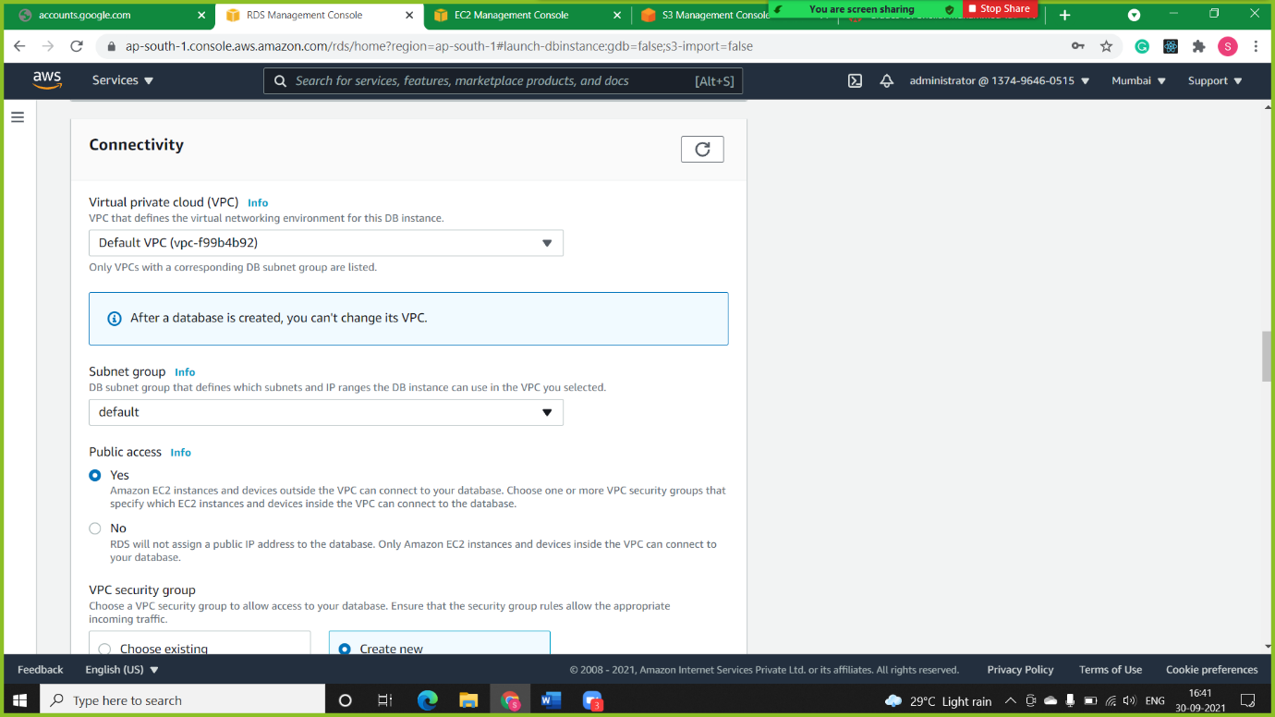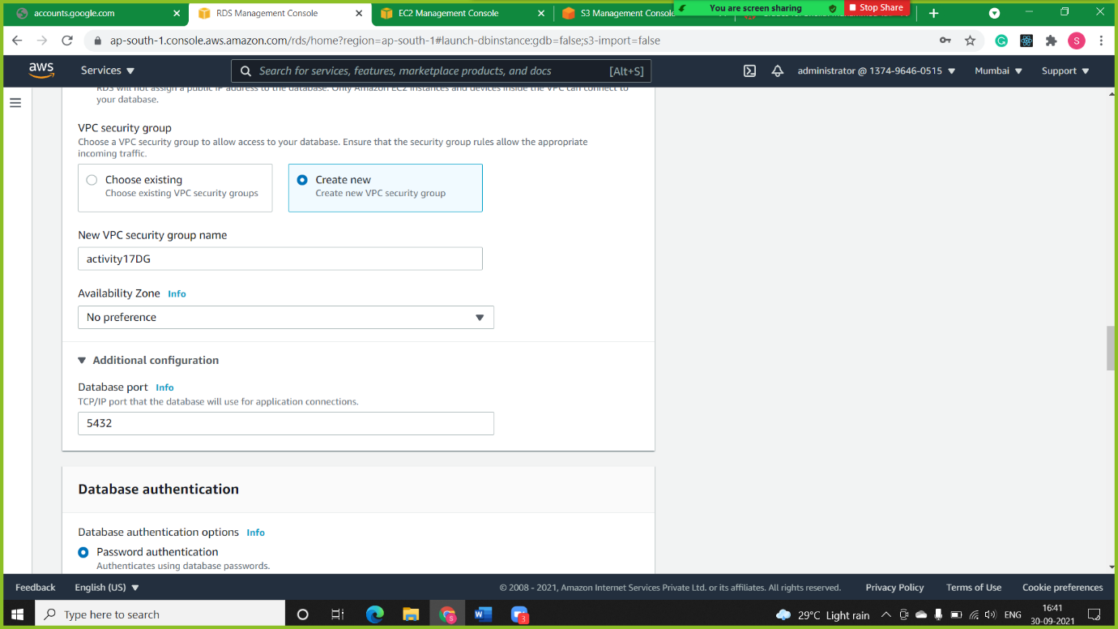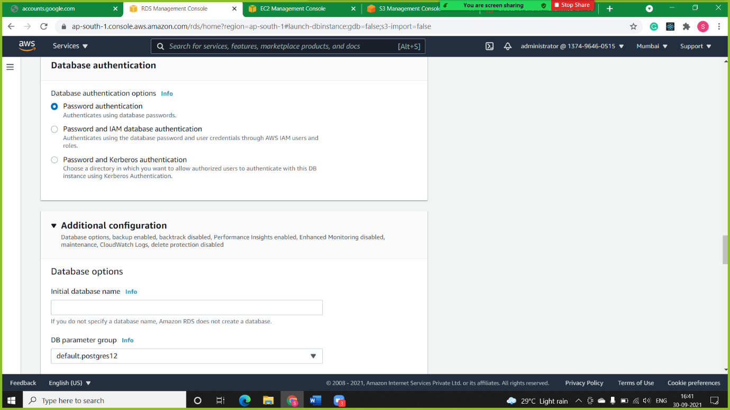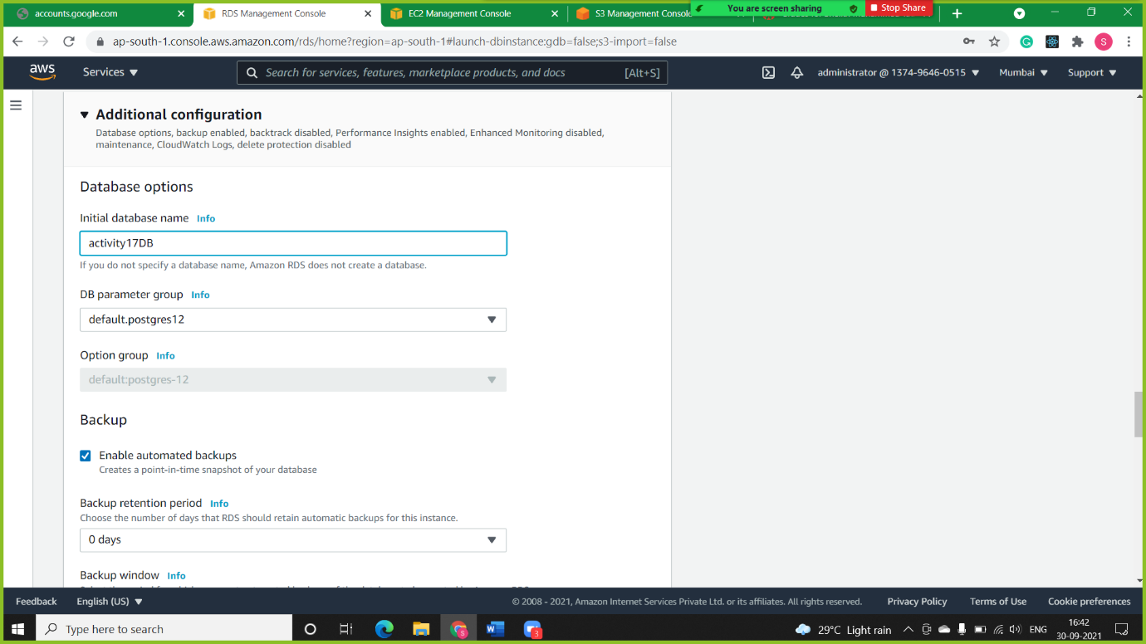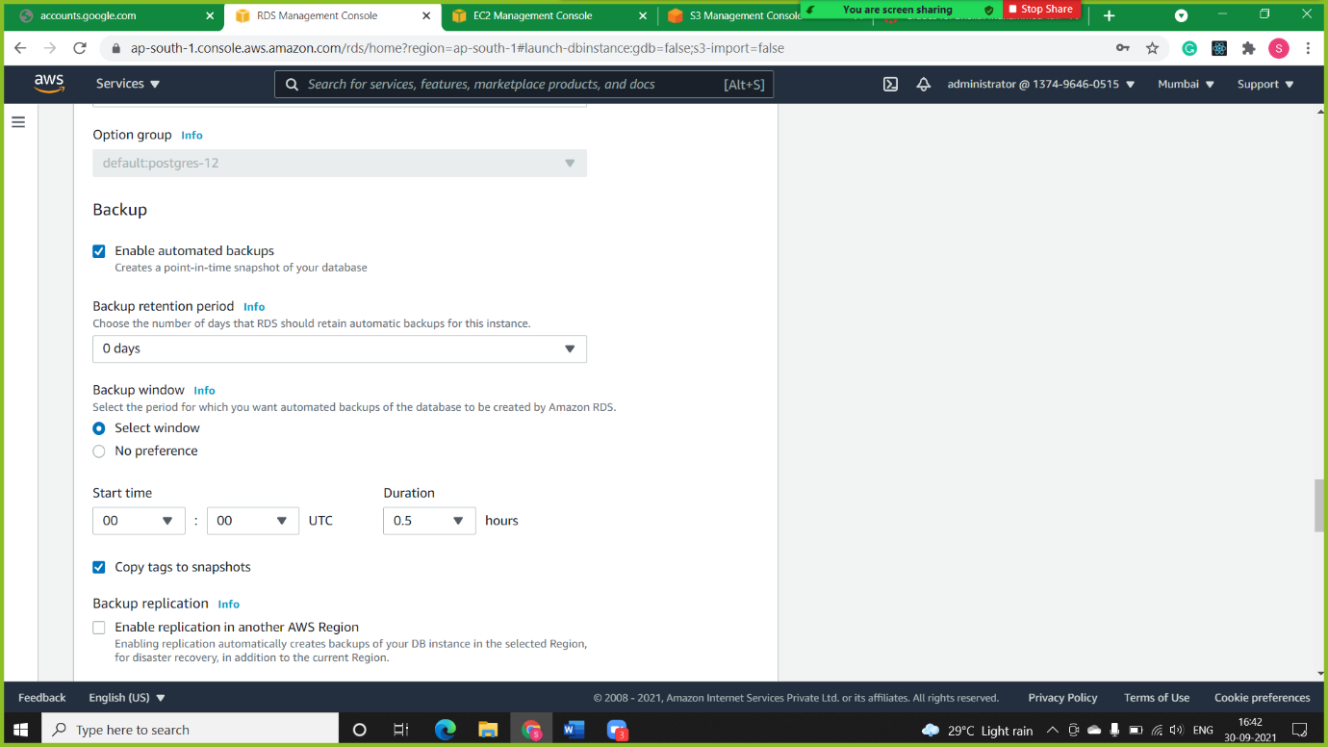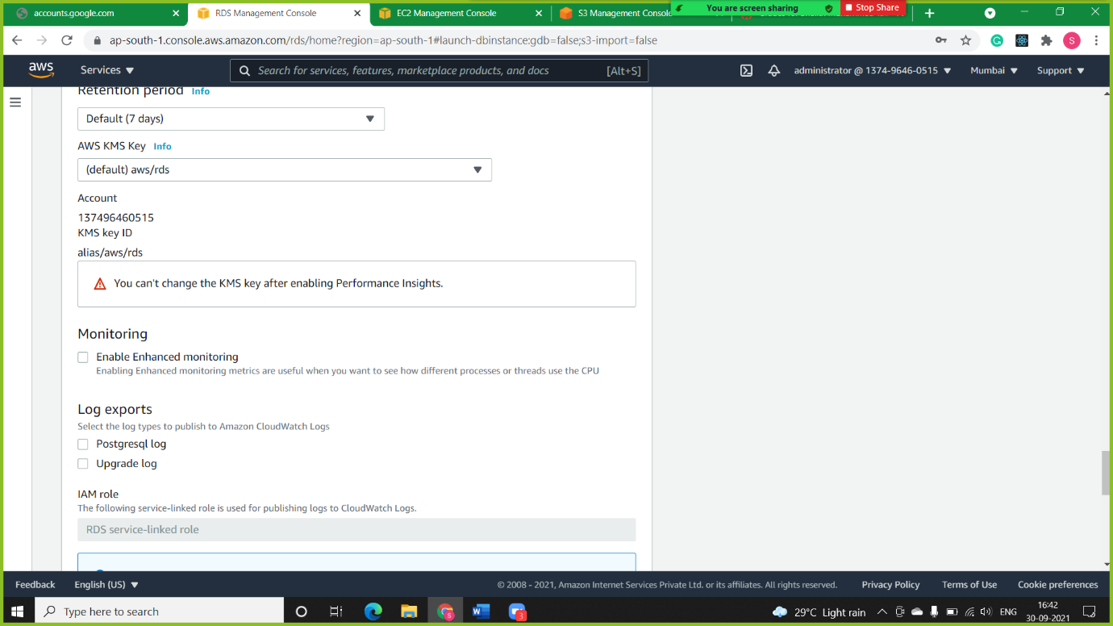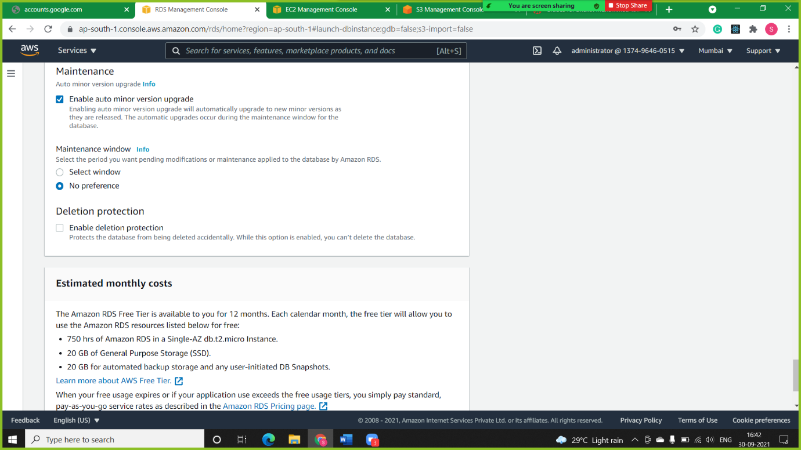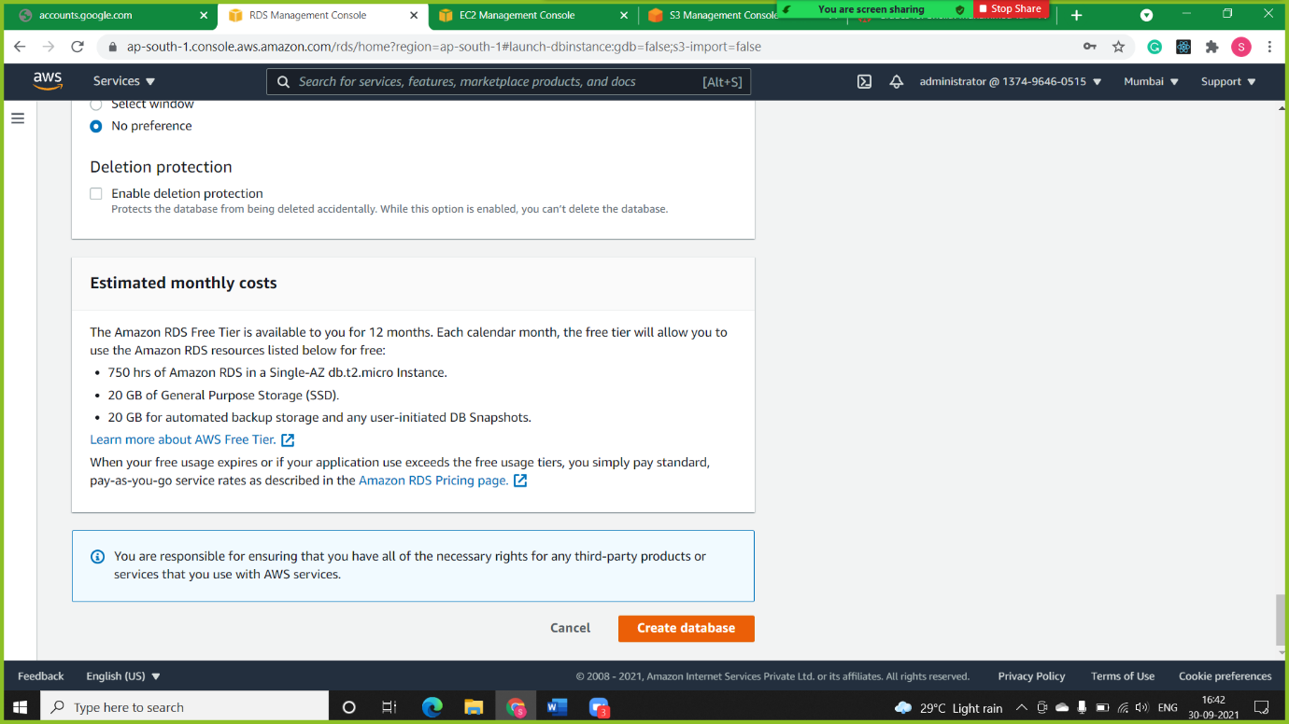

In Below Screenshot we can see the database created successfully

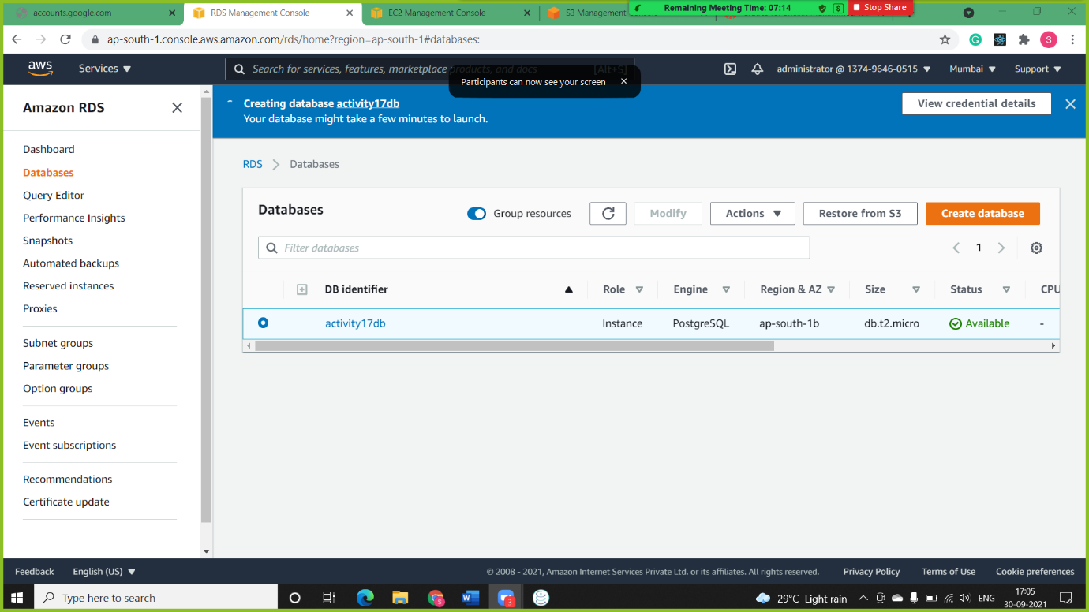

**Step 2:** Connecting the created Database to Sqlectron.

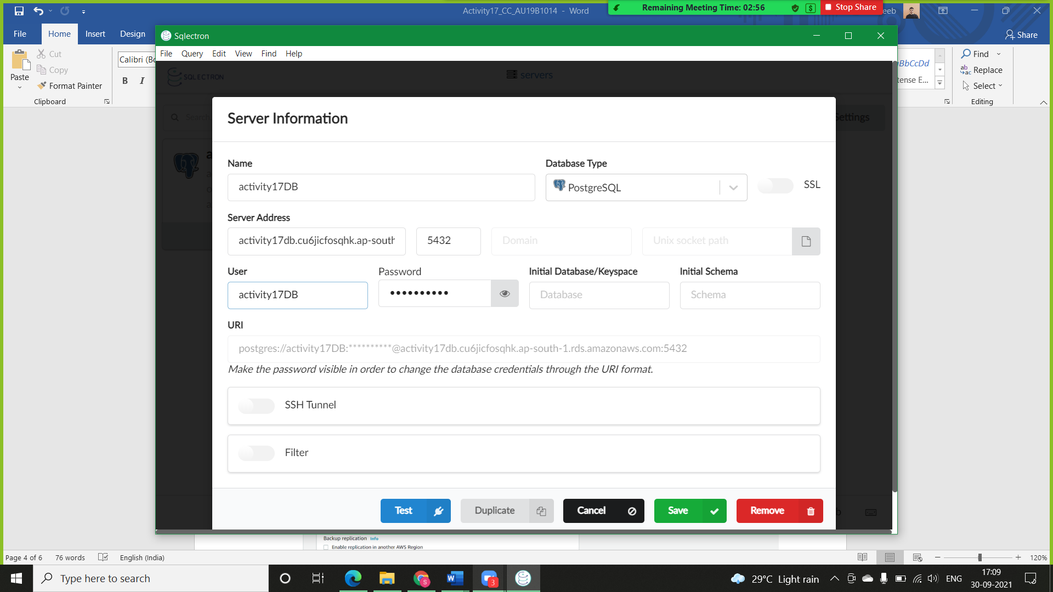

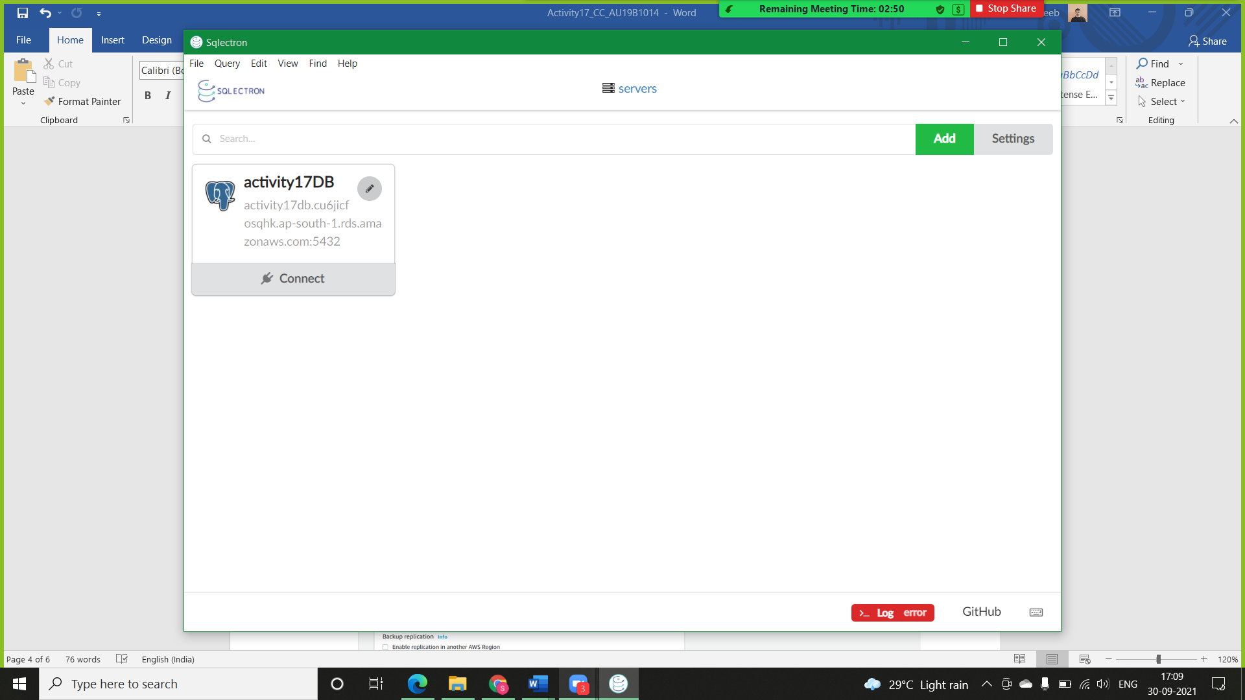

**Step 3:** Creating Table with MySQL commands.

* **Table 1:**

Books, with attribute as Name, Pages, Cost and Language.

* **Command:**

1. create table Books (Name varchar (30), Pages int, Cost float, Language varchar (30));

1. select*from Books;

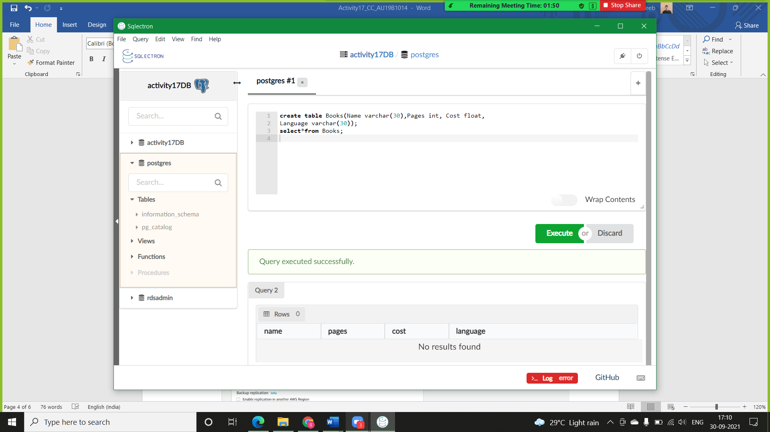

* **Table 2:**

Movies, with Attribute, Movie Name, Actor, Director, Release Year.

* **Command:**

1. create table Movies (Movie_Name varchar (30), Actor varchar (30), Director varchar (30), Release_year int);
2. select*from Movies;

